Public

amnesty international

Iraq
People come first
Amnesty International's 10-point appeal to all parties involved in possible military action in Iraq

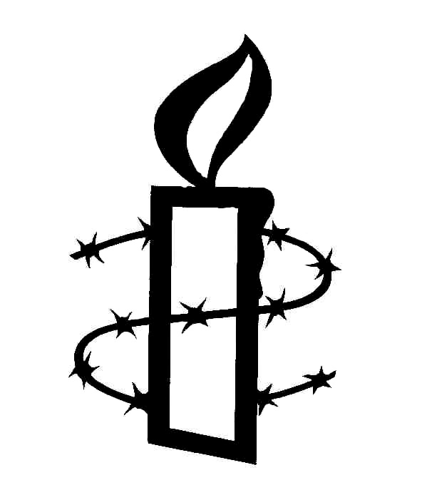

March 2003
People come first

Amnesty International’s 10-point appeal to all parties
involved in possible military action in Iraq

18 March 2003
MDE 14/022/2003

Amnesty International is calling on all parties that may be involved in military action in Iraq to publicly commit themselves to 10 specific demands aimed at maximizing the protection of civilians and others who would be affected by war.

The United States of America and allied governments intending to launch a military action against Iraq have a particular responsibility to ensure that international human rights and humanitarian law are fully upheld. While thinking is clearly being given to develop military strategies, Amnesty International is concerned that it has not heard about specific measures to mitigate the consequences of war.

Amnesty International also calls on the government of Iraq and any armed group that may be involved in the hostilities equally to abide by their obligations under international law in the event of war.

All other states should do everything in their power to ensure respect for fundamental norms of humanity by all parties concerned. The 1949 Geneva Conventions, enjoying near universal ratification, include an obligation on all state parties not only to respect but also to ensure respect for the Conventions by all other parties.

1. All parties must adhere strictly to the rules of international humanitarian law regarding the protection of civilians

All parties must refrain from targeting civilians or civilian objects. They should strictly adhere to the definition of military objective and the prohibition of indiscriminate and disproportionate attacks contained in Protocol I Additional to the Geneva Conventions, which reflect customary international law. In particular, there should be:

- no direct attack on civilians or civilian objects;
- no attack on the infrastructure even if used for military purposes, if the incidental short-term and long-term consequences for civilians would be disproportionate to the concrete and direct military advantage sought in the specific attack;
- no attack on media outlets solely because they are being used for propaganda purposes; and
- no attack on other civilian objects even if their destruction is deemed by the attacker to be likely to lessen the will of the enemy to fight.

All parties must take all necessary precautions to spare civilians, including by ensuring that military objectives are located away from civilian areas, issuing warnings to civilians wherever feasible and by refraining from using civilians as “human shields”.

2. All parties must refrain from using weapons which are inherently indiscriminate or otherwise prohibited under international humanitarian law

No party should use chemical, biological or nuclear weapons, including in reprisal. Anti-personnel land mines and cluster weapons should not be used. Given that their long-term medical effects are still uncertain, parties should refrain from using depleted uranium weapons.

3. Civilian detainees must be treated fairly and humanely

Human rights provisions and those of the Fourth Geneva Convention Relative to the Protection of Civilian Persons in Time of War, including those dealing with occupied territories, must be fully respected.

Civilians in detention, including third party nationals, must be treated in accordance with all internationally recognized human rights safeguards on detention. They should not be held on discriminatory or otherwise arbitrary grounds, be ill-treated in any way, or held in incommunicado detention. They must be provided with an opportunity to challenge the lawfulness of their detention. They should be released if they are not to be charged or tried within a reasonable time.

4. All parties must protect the rights of combatants

Captured combatants must be treated in full compliance with the rules of the Third Geneva Convention Relative to the Treatment of Prisoners of War and Protocol I. Under no circumstances are they to be tortured or ill-treated, or handed over to third parties if they would be at risk of such treatment.

No person under the age of 18 should be conscripted or recruited into armed forces nor should any participate actively in hostilities.

In addition to the specific treaty rules of international humanitarian law, all parties should act bearing in mind that combatants as well as civilians remain at all times “under the protection and authority of the principles of international law derived from established custom, from the principles of humanity and from the dictates of public conscience” (Article 1(2) of Protocol I).

Military necessity must always be balanced by the principles of humanity, and all unnecessary suffering including that of enemy soldiers must therefore be avoided. In this context, whenever possible parties should seek to capture rather than kill enemy combatants.

5. All parties must take measures to ensure that the security and humanitarian needs of the Iraqi population are fully met

Military action may lead to renewed human rights abuses by the Iraqi authorities, armed opposition groups, other parties involved in the military operations, and reprisals on ethnic or other grounds. Women may be at particular risk in such an environment. All parties to a conflict have a responsibility to ensure the safety and security of those in territories under their control, and take measures to prevent and repress abuses by their own troops and those of allied countries or armed groups.

All parties must ensure that the humanitarian needs of the Iraqi population are fully met, including by ensuring the provision of food, water, shelter, sanitation and medical care. Denial of humanitarian access by states or non-state actors is a violation of human rights and humanitarian law. The Iraqi authorities and the military authorities of any forces entering Iraq must facilitate access and the operations of humanitarian organizations.

6. All parties must ensure protection and assistance for refugees and internally displaced persons

States neighbouring Iraq must keep their borders open and provide protection and assistance to Iraqi refugees, in accordance with the 1951 Convention relating to the Status of Refugees and its 1967 Protocol. The international community at large must share this responsibility with the neighbouring states. The Office of the United Nations High Commissioner for Refugees must be given full access and cooperation by all relevant parties.

No security procedures for those fleeing Iraq should obstruct their right to seek asylum in other countries, nor should such systems operate in a discriminatory or arbitrary fashion.

The 1998 United Nations Guiding Principles on Internal Displacement must guide any action to ensure protection and assistance for Iraqis who are already displaced within Iraq or may be displaced as a result of war.

7. All parties must ensure a comprehensive approach for bringing to justice perpetrators of crimes under international law

There should be individual accountability. All parties must ensure a comprehensive set of measures for bringing to justice, in proceedings fully consistent with internationally recognized standards for fair trial, those responsible for crimes under international law such as torture, genocide, war crimes and crimes against humanity.

Priority must be given to rebuilding and reforming the justice system in Iraq in conformity with international human rights standards. In parallel, other states should fulfil their obligations under international human rights and humanitarian law and bring to justice, before their own courts, perpetrators of crimes under international law, in implementation of the principle of universal jurisdiction.
States involved in a conflict in Iraq who have not yet ratified the Rome Statute of the International Criminal Court should recognize the Court’s jurisdiction by making a declaration under Article 12(3) of the Rome Statute.

Beyond the need to ensure accountability for crimes committed by any party during any military action, accountability for past human rights abuses in Iraq must be ensured.

There should be no statute of limitations and no amnesties, pardons or similar measures for crimes under international law if such measures would prevent the emergence of the truth, a final judicial determination of guilt or innocence, and full reparation for the victims and their families. No defence of superior orders should be accepted in any circumstances.

8. All parties should declare their readiness to use the services of the International Humanitarian Fact-Finding Commission

All parties to the conflict should commit themselves to seek the services of the International Humanitarian Fact-Finding Commission, established under Article 90 of Protocol I, to investigate incidents where serious violations of the Geneva Conventions and the Protocol are alleged to have taken place. Under Article 90(2)(d), parties to the conflict that are not parties to Protocol I can still request the Commission to institute an inquiry with the consent of other parties concerned.

Scrutiny by the Commission will be essential to ensure that in any dispute over specific incidents the facts are independently and authoritatively established and appropriate follow-up action recommended.

9. All parties must support and facilitate the deployment of human rights monitors throughout Iraq as soon as the security situation permits

The deployment of United Nations human rights monitors in Iraq was first called for by Amnesty International in 1991 and is a long-standing request of the General Assembly and the Commission on Human Rights.

Human rights monitors should have been deployed already in Iraq. They would be just as crucial to the protection of human rights in the immediate aftermath of conflict and subsequently as part of a program of human rights reform. In addition to providing a measure of protection by proactively addressing human rights cases and issues, human rights monitors would provide authoritative and timely information and analysis on human rights developments in Iraq.

The mandate of the human rights monitors should cover human rights abuses in Iraqi territory by any party, including the Iraqi government, any armed group allied or opposed to the Iraqi government, and any other party that may exercise control over Iraqi territory.

As in the past, human rights monitors can be deployed flexibly, including in neighbouring countries on a temporary basis, depending on the situation. It is essential that arrangements for the speedy deployment of sufficient numbers of qualified human rights monitors are made now, with all the necessary resources made available.

10. All parties must support the United Nations in carrying out their humanitarian and human rights responsibilities

All parties and the international community at large must ensure that United Nations organs and agencies can exercise effectively their humanitarian and human rights responsibilities with regard to the situation in Iraq.

The Security Council in particular should closely monitor the adherence of all parties to international human rights and humanitarian law, and request regular reporting from the governments involved.

The General Assembly and the Commission on Human Rights should take steps to ensure that their longstanding recommendations for the protection of human rights in Iraq are implemented without further delay. The relevant mechanisms of the Commission on Human Rights should look into the situation and contribute to the development of a long-term program of human rights protection and promotion in Iraq.

/ENDS

