EUROPEAN COUNCIL
ON REFUGEES AND EXILES





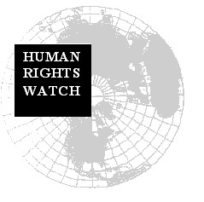



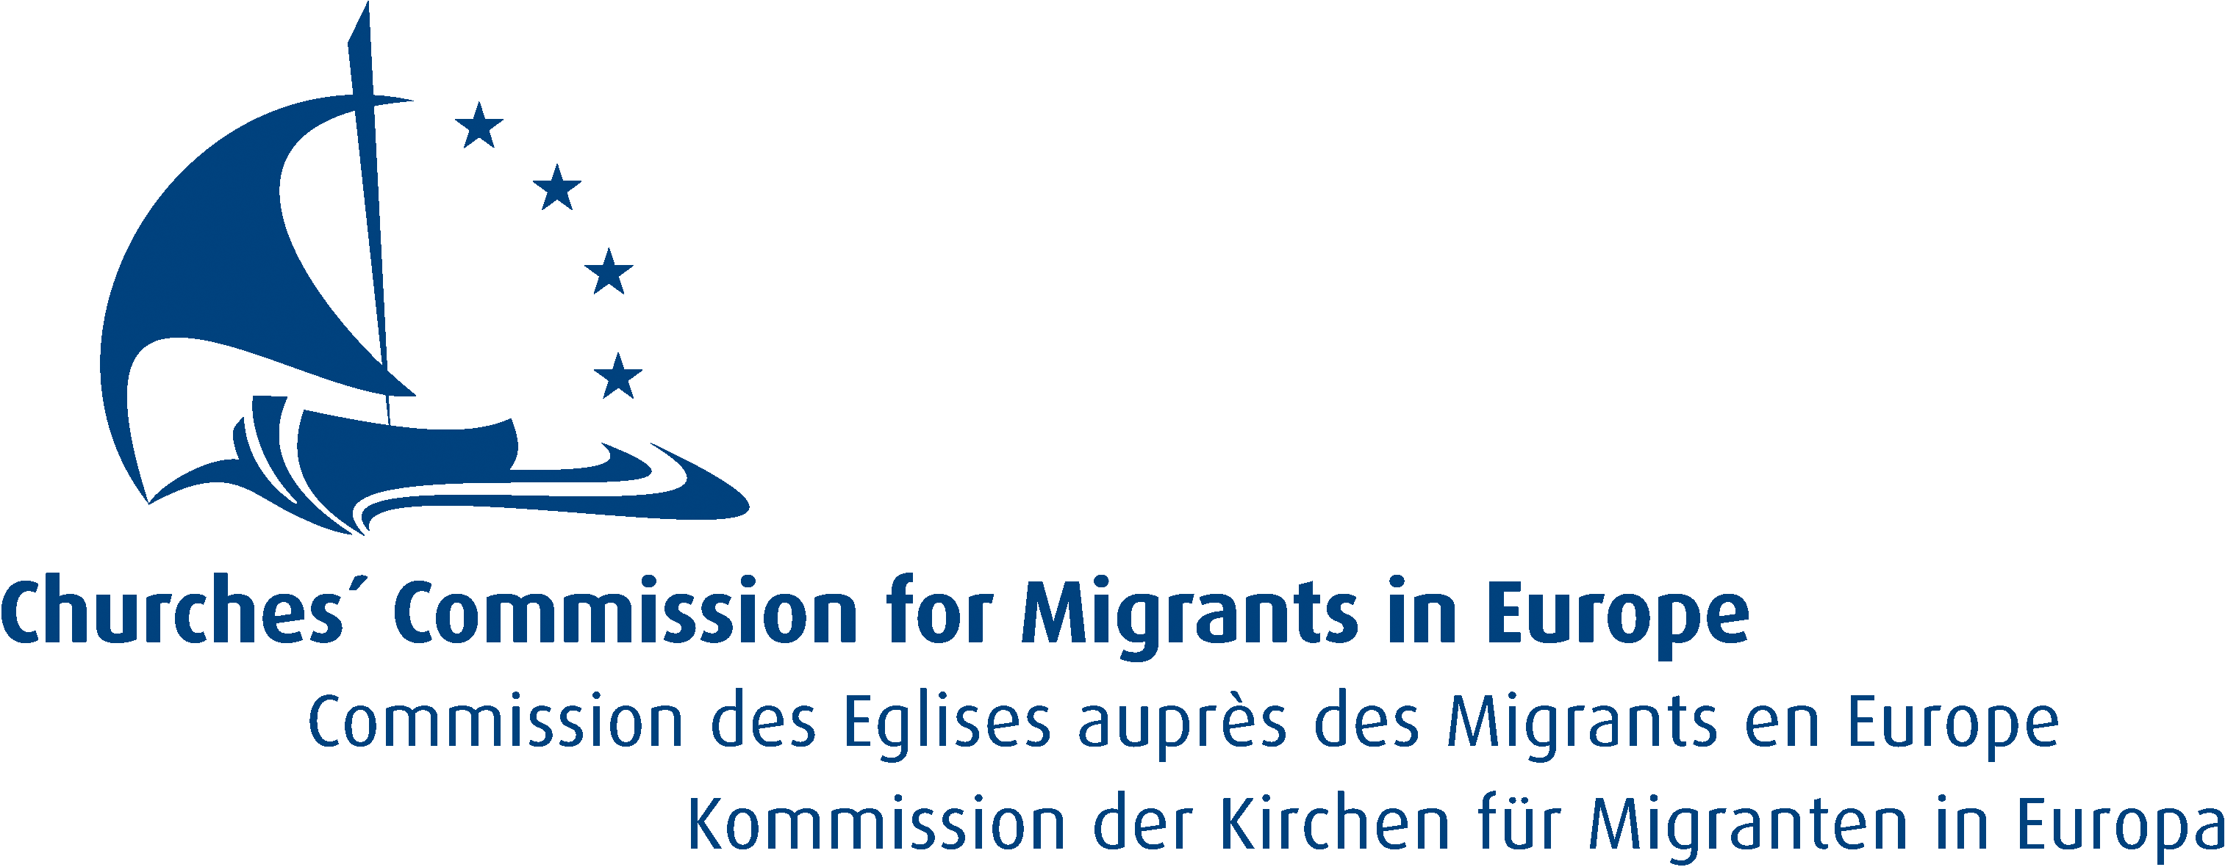



Bruxelles, 14 September 2004

Object: Parliamentary hearing of the Commissioner-designate for Justice, Freedom and Security, Mr Buttiglione

Dear Sir, Dear Madam,

In view of the forthcoming hearing of the Commissioner-designate for Justice, Freedom and Security, Mr Buttiglione, the undersigned organizations wish to draw your attention to questions of major concern to NGOs working on EU asylum, refugee and migration policy development. These NGOs are working together in the NGO Platform on EU asylum and migration issues in the EU and we are enclosing some background information on the Platform. Our questions also reflect concerns that were already raised by the office of the United Nations High Commissioner for Refugees.

…/…

Regarding the transposition phase:

- The European Council has agreed on several Community laws on asylum as required by the Amsterdam Treaty, in the first phase of establishment of a common European asylum system. The Commission is responsible for monitoring and reporting on progress in transposing the relevant legal texts into Member States’ national law and their implementation. What steps will the Commissioner-designate take to prioritize this monitoring exercise?

- Will the Commissioner-designate take proactive steps within the Commission’s power, including legal action where necessary, against Member States which fail to fulfill their obligations correctly to transpose and implement Community Directives on asylum?

Regarding the second phase of a Common European Asylum System:

- On the basis of the provisions of the new constitutional treaty (Art. III-167), Member States have agreed to establish a common asylum procedure and uniform status of asylum valid throughout the Union. How does the Commissioner-designate intend to ensure that the second phase of the harmonization process fully complies with the principles endorsed by the conclusions of the 1999 Tampere European Council i.e. a full and inclusive implementation of the 1951 Geneva Convention and the absolute respect of the principle of non-refoulement? In particular, how does the Commissioner-designate intend to promote the protection of vulnerable asylum-seekers, such as unaccompanied children?

- In light of recent initiatives to combat illegal immigration through partnership with countries of origin and transit, including suggestions to establish transit camps in North Africa, and the interception of boats, how will the Commissioner-designate ensure that these measures will not hamper access to asylum procedures for persons in need of international protection? How will the Commissioner-designate ensure that this policy is in full compliance with the objectives of the Barcelona process, which states that the relations between parties shall be based on the respect of democratic principles and fundamental human rights?

- How does the Commissioner-designate intend to further work towards developing the open-method of co-ordination, including by developing common tools for a joint assessment the situation in sending and transit countries, which is a key element in achieving an equivalent level of protection throughout the EU?

Regarding the development of an EU Migration Policy:

- How does the Commissioner-designate intend to reinvigorate the proposals launched by his predecessor and aimed at developing legal channels of migration and a proper integration policy? Will the Commissioner-designate actively support the ratification of the International Convention on the Protection of the Rights of All Migrant Workers and Members of their Families as an essential tool for fighting against discrimination and labor exploitation?

- Current debates in EU Member States have stressed the critical need to further reinforce the fight against trafficking of human beings and to strengthen the protection of victims. How does the Commissioner-designate intend to further develop the action of the European Union in this field?

Holly Cartner
Executive Director
Europe and Central Asia Division
Human Rights Watch

Clara Odofin,
Head of Policy & Advocacy
ECRE

Nele Verbruggen
Coordinator
PICUM (Platform for International Cooperation on Undocumented Migrants)

Dick Oosting
Director
Amnesty International European Union Office

Diana Sutton
European officer
Save the Children

Etienne De Jonghe
International Secretary
Pax Christi International

Doris Peschke,
General Secretary
CCME

Cornelia Buehrle - RSCJ
Advocacy and Policy office
Jesuit Refugee Service Europe

